**HAI Assignment 1**

241110038 - Krishna Kumar Bais

241110057 - Rohan

**Assumptions:**

The student is familiar to Pingala portal and IITK academics.  
We are just integrating the Course Recommendation system in it.

**Screen 1:**

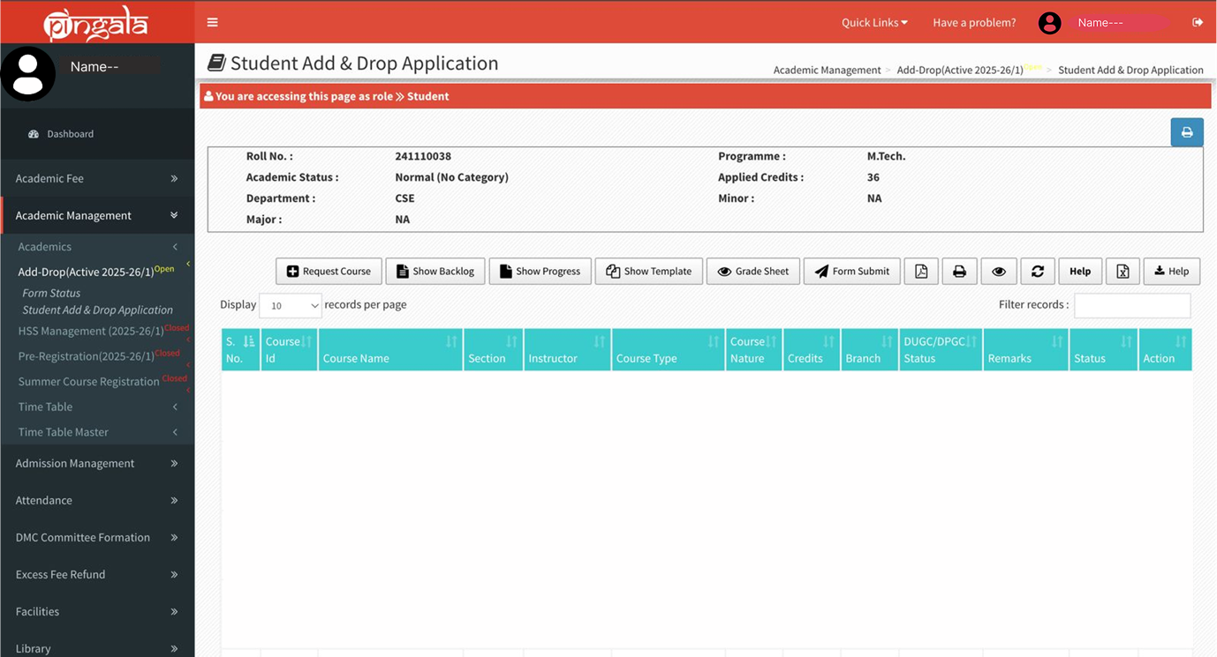

The whole interface and functionality are same as of Pingala portal.

After clicking the “request course” button the screen will change to “Screen 2” which will have AI system for course recommendation.

**Screen 2:**

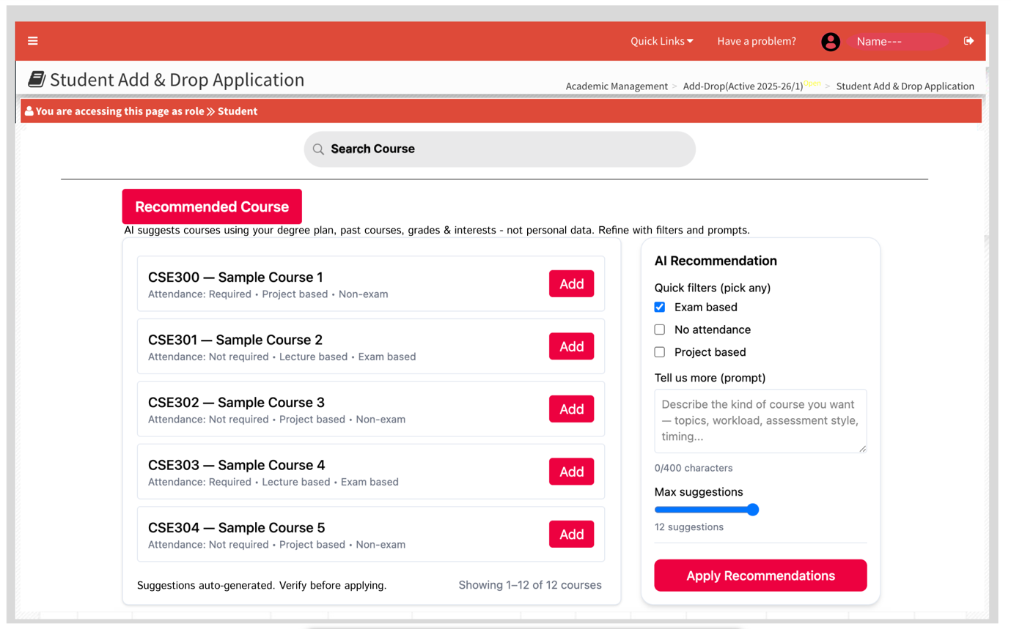

This screen contains the recommendation AI system that recommends courses to student. Initially this screen will not show any courses. It shows courses only after students clicks “Apply Recommendations” button. If no match it shows message “No strong matches found - kindly adjust filters or browse electives”.

The recommendation is based on the “Quick filters”. The student can also write up their prompt to get the personalised course recommendation.

The “Max Suggestion” slider will tell the AI system about number of courses to be recommend.

The “Search Course” is a predictive search field that will show the courses based on text input as in Screen 2.A.

Here, the student can select the “Add” button to add that course. After clicking the “Add” button the above “Search Course” field will get updated according to “Screen 3”.

**Screen 2.A :**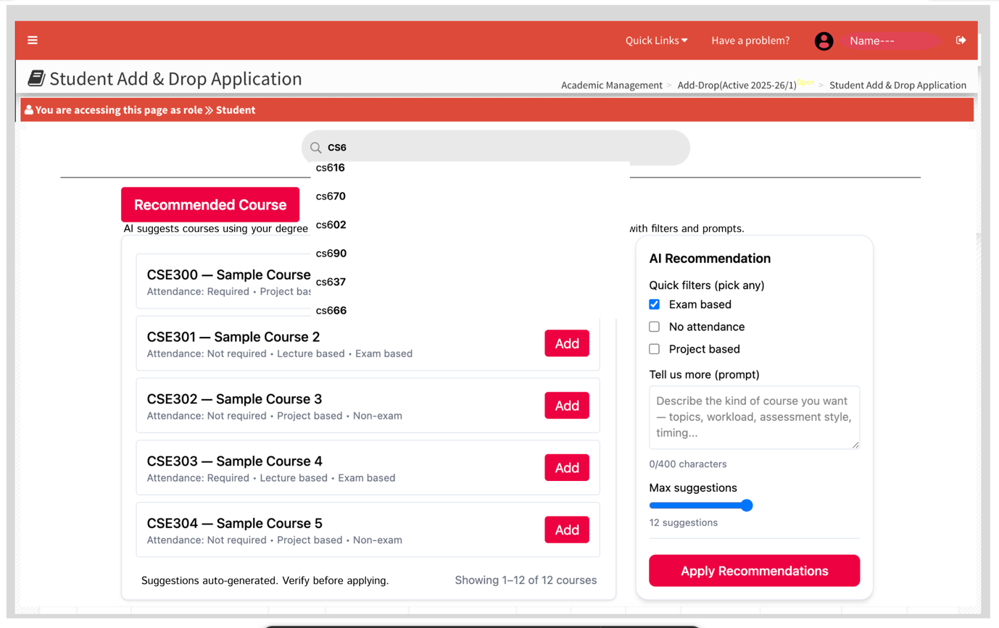

When student searches a particular course using “Search Course” field, that will show the courses based on text input.  
And if student taps on option then screen will change to Screen 3.

**Screen 3:**

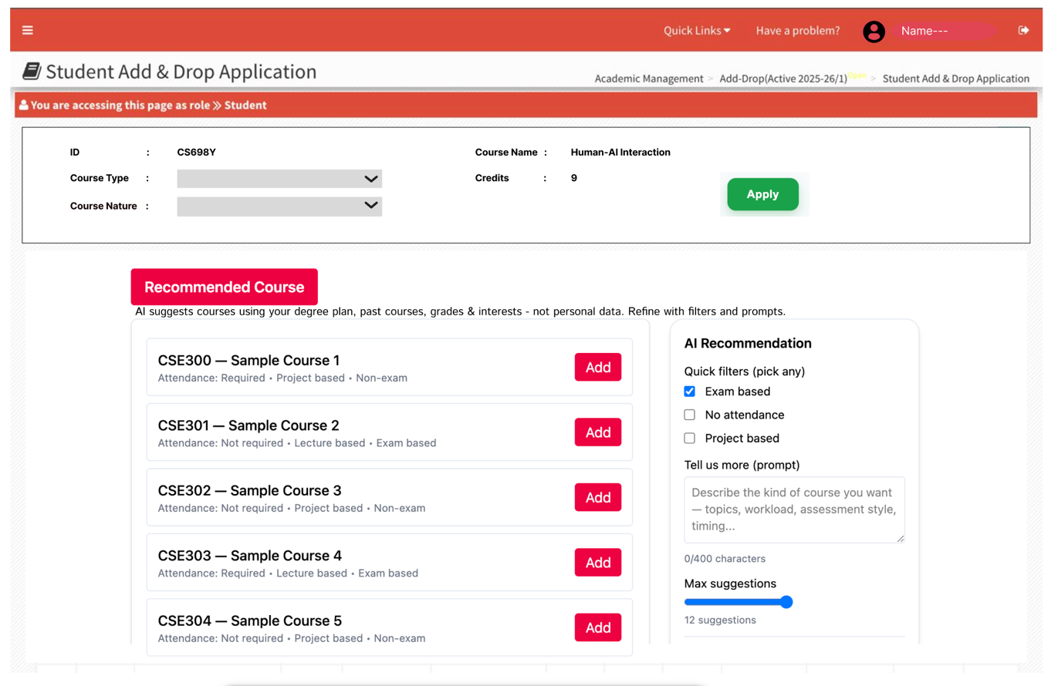

This screen will get updated after the student clicks “Add” button of the recommended courses. OR When student searches a particular course using “Search Course” field in previous screen.

In this screen the details of selected course will be shown along with a “Apply” button to apply for that course. This will also show Prerequisite for that course if any.

After applying a course, a pop will show that “course is added, to check visit previous screen”.

**HAX Guideline Implementation — Pingala Course Recommender**

**G1 - Make clear what the system can do**

**Implemented:** Yes  
**How:** Screen 2 shows “Recommended Courses” label with red colour, displays the banner: “AI suggests courses using your degree plan, past courses, grades & interests - not personal data. Refine with filters and prompts.” and text prompt placeholder: “Describe the kind of course you want - topics, workload, assessment style, timing…”  
This clearly indicating below section will show courses recommended by AI system.

**G2 - Make clear how well the system can do what it can do**

**Implemented:** Yes  
**How:** A global disclaimer is visible: **“Suggestions auto generated. Verify before applying.”** We can also show relevance tags on cards (High / Medium / Low) if desired.

**G3 - Time services based on context**

**Implemented:** Yes **How:** The recommender is invoked only when the user clicks “Apply Recommendations, edits the prompt, or adjusts filters”.

**G4 - Show contextually relevant information**

**Implemented:** Yes  
**How:** Recommendation cards show “course name, code, credits” and relevance tags; Quick Filters and the Prompt box let user's narrow results; predictive search helps find specific courses.

**G5 - Match relevant social norms**

**Implemented:** Yes  
**How:** Language, labels, and tone match Pingala’s formal academic style (e.g., “credits”, “prerequisite”, “Apply”).

**G6 - Mitigate social biases**

**Implemented:** Yes  
**How:** You explicitly state in the banner that the AI uses degree plan, past courses, grades & interests and **“not personal data”**.

**G7 - Support efficient invocation**

**Implemented:** Yes  
**How:** “Request Course” button on the registration page and accessible prompt/search box in Screen 2. The courses will only be recommended when student clicks the “Apply Recommendation” button.

**G8 - Support efficient dismissal**

**Implemented:** No  
**Why:** Users can avoid invocation but once the recommended course will show there is no single-click dismiss.  
This is because the current Pingala system works the same. After applying a course the student remains on the same page (the course is added to the list on previous page). So, to keep the familiarity same for the current users of Pingala, we did not add a dismissal option.  
It can be added as a “Close” Icon on the top right of “Recommended Course” section.

**G9 - Support efficient correction**

**Implemented:** Yes  
**How:** Quick Filters, the Prompt box (with the new descriptive placeholder), Max Suggestion slider, and predictive search let users refine recommendations iteratively.

**G10 - Scope services when in doubt**

**Implemented:** Yes  
**How:** When there are no matches, the UI shows a fallback message (“No strong matches found - kindly adjust filters or browse electives”.

**G11 - Make clear why the system did what it did**

**Implemented:** Yes  
**How:** Each recommended course displays written rationale (“attendance required”, “project-based”, “non-exam”, etc).

**G12 - Remember recent interactions**

**Implemented:** Yes  
**How:** Session memory saves the last filters, last prompt, and recently accepted/rejected suggestions and preloads them when the panel is reopened.

**G13 - Learn from user behaviour**

**Implemented:** Yes  
**How:** Learning is based on accepted and rejected courses which is used to personalize future recommendations across sessions.

**G14 - Update and adapt cautiously**

**Implemented:** Yes  
**How:** Screen will display small notices when recommendation logic changes and offer an “old vs new” comparison for a limited time.

**G15 - Encourage granular feedback**

**Implemented:** No  
**Why:** I did not include feedback options such as thumbs-up/thumbs-down or reason selection for individual course recommendations because: “Time-sensitive portal use” meaning Pingala is mainly used during course registration, where students prefer quick actions. Adding rating interactions could slow them down.Future scope:  
Feedback could be added in later iterations with simple per-course options (👍/👎 and optional reasons like “Already completed” or “Not relevant”). This would let the recommender adapt over time while keeping the UI clean.

**G16 - Convey the consequences of user actions**

**Implemented:** Yes  
**How:** The Max Suggestion slider controls number of results along with quick filters and prompts.

**G17 - Provide global controls**

**Implemented:** Yes  
**How:** Options like checkbox, slider, text input will be controlled by student.

**G18 - Notify users about changes**

**Implemented:** Yes  
**How:** Notifications are planned for new matching courses, recommendation-logic changes, and prerequisite changes via Pingala notifications and optional email.